PROJECT PROPOSAL
Smart Provincial M&E Management Ecosystem
A Unified Digital Platform for Scheme Information, Field Monitoring, and Financial Oversight
Comprising SIMS · PMS · Finance Dashboard

Prepared for: Provincial Planning & Development / Monitoring & Evaluation Cell
Document Type: Software Project Proposal & Technical Documentation
Prepared by:
Muhammad Mustafa & Rizwan Vadsariya
Development Team (2 Members)
Date: September 2026 | Version: 1.0

Table of Contents
1. Executive Summary
2. Project Background & Problem Statement
3. Proposed Solution & Objectives
4. Project Scope
5. System Overview & Core Modules
6. User Roles & Access Control
7. End-to-End Workflow
8. Mobile Application & FMO Field Workflow
9. Location Verification & Field Evidence Security
10. Offline-First Operation
11. Financial Monitoring & Variance Engine
12. System Architecture & Technology Stack
13. Data Model
14. Functional & Non-Functional Requirements
15. Development Roadmap
16. Testing Strategy
17. MVP Scope & Future Enhancements
18. Conclusion

1. Executive Summary
The Smart Provincial M&E Management Ecosystem is a proposed digital platform for monitoring development schemes across Sindh Province. It replaces fragmented, manual, document-based tracking with a single, role-adaptive system connecting scheme registration, field verification, and financial oversight.
The ecosystem consists of three integrated components — SIMS (Scheme Information Management System), PMS (Project Monitoring System), and a Finance Dashboard — connected by a Variance Engine that cross-checks financial expenditure against verified physical progress to surface discrepancies requiring management attention.
The system will be delivered as a single role-adaptive React Native mobile application, supported by a centralized Node.js/Express backend and a MongoDB database. Field Monitoring Officers use a dedicated Field Mode with GPS/geofence verification, live in-app camera capture with automatic evidence watermarking, and offline-first data capture with background synchronization. Configurable values referenced in this document (e.g., geofence radius, variance thresholds) are explicitly labelled as proposed defaults pending organizational confirmation.

2. Project Background & Problem Statement
Provincial development authorities oversee a large, diverse portfolio of schemes across sectors such as infrastructure, roads, bridges, health, education, energy, public health engineering, water & sanitation, and finance — spread across multiple divisions, districts, and project sites. Scheme information today tends to exist in scattered form across departments, physical files, and spreadsheets, with no single authoritative source management or field staff can rely on.

Core Problems Addressed
- Lack of a centralized, province-wide source of scheme information.
- Difficulty monitoring projects consistently across districts, divisions, and sectors.
- Weak field verification — no reliable way to confirm reported progress reflects ground reality.
- Unverified photo evidence, which may not originate from the actual project site.
- No structured mechanism to verify a field officer's presence at a site.
- A disconnect between financial expenditure and actual physical progress.
- Delayed identification of stalled, halted, or problem projects.
- Lack of real-time dashboards, GIS visibility, and automated alerts for management.

3. Proposed Solution & Objectives
The system addresses these problems through a centralized scheme registry, GPS-verified field inspections with tamper-resistant evidence, structured financial tracking, and an automated Variance Engine.

Illustrative Example
A road scheme in Hyderabad has an approved budget of Rs. 100 Crore. Financial records show 80% of the budget spent, while a field inspection verifies only 30% physical completion.
Variance Index = Financial Expenditure % − Physical Progress % = 80% − 30% = 50%
A 50% variance is a Red Flag, automatically surfaced on the dashboard for management review and follow-up action.

Key Objectives
- Provide a single digital registry for all schemes, including PC-I and approval documents.
- Track scheme locations and boundaries using GIS.
- Enable inspection dispatch, GPS-verified field visits, and authentic evidence capture.
- Track financial allocation, releases, and expenditure per scheme.
- Automatically detect and flag financial-physical variance.
- Provide consolidated dashboards, alerts, and an auditable activity trail.

4. Project Scope

4.1 In Scope
- SIMS: scheme registry, document management, GIS mapping.
- PMS: inspection dispatch, FMO Field Mode, GPS/geofence verification, live camera + watermarking, milestone progress, issue reporting.
- Offline-first field capture with background synchronization.
- Finance Dashboard and the Variance Engine.
- Executive dashboards, alerts, notifications, and audit logging.

4.2 Out of Scope
- Direct integration with government treasury or fund-disbursement systems.
- Automatic transfer or freezing of real government funds.
- Connection to production government databases or confidential systems.
- Real government identity infrastructure or legal enforcement actions.
Note: Any "fund-freeze" or similarly serious action surfaced by the system is an authorized administrative recommendation requiring human approval — never an automatically executed control over real government funds.

5. System Overview & Core Modules
Every scheme has one centralized record: identity (Scheme ID, sector, department), location (district, division, GPS, boundary), execution details (contractor, engineer, dates), documentation (PC-I, approvals), financials (allocation, releases, expenditure), and monitoring history (progress, inspections, issues, photos).
Module | Function
SIMS | Centralized scheme registry, document management, and GIS mapping.
PMS | Inspection dispatch and GPS-verified field progress tracking.
Finance | Budget allocation, fund releases, and expenditure tracking.
Variance Engine | Cross-checks financial expenditure against verified physical progress.
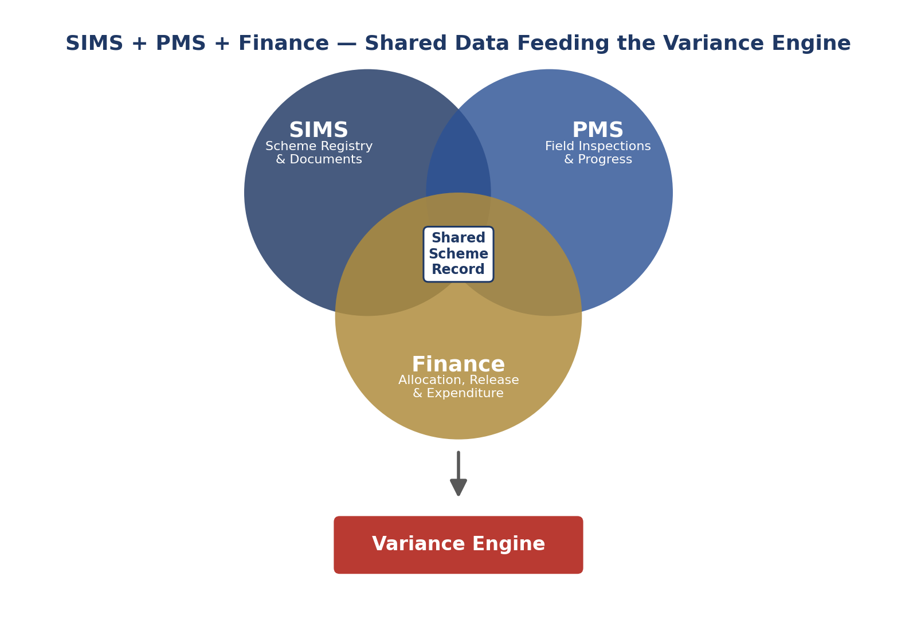
Figure 1 — SIMS, PMS, and Finance share one scheme record that feeds the Variance Engine

5.1 Illustrative Executive Dashboard
The mockup below illustrates the kind of at-a-glance KPI view the executive dashboard will present to management, using sample data for illustration only.
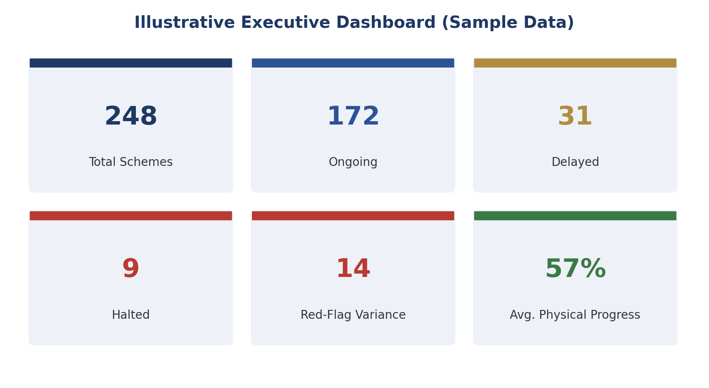
Figure 2 — Illustrative executive dashboard (sample data, not actual figures)

6. User Roles & Access Control
The application is fully role-based: after login it renders the dashboard, navigation, and actions appropriate to the authenticated user's role.
P&D / MEC Central → Line Department Head → Regional Director → Field Monitoring Officer
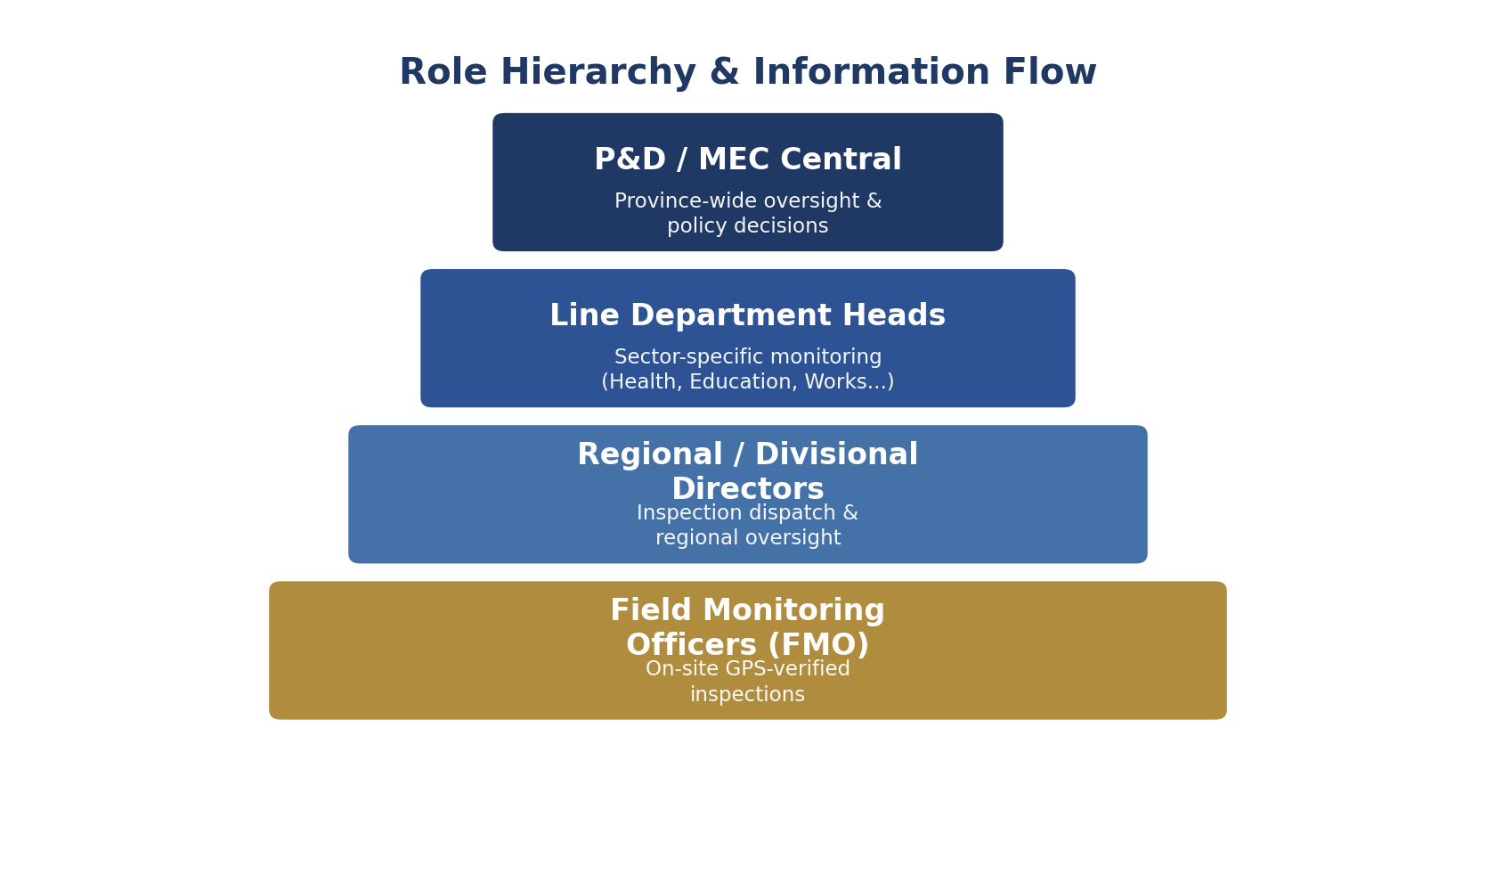
Figure 3 — Role hierarchy and information flow
Role | Primary Responsibilities
P&D / MEC Central | Province-wide KPIs, GIS map, financial summaries, red flags, escalations, and management reports.
Line Department Head | Monitors sector-specific schemes, reviews inspection reports and discrepancy notices.
Regional / Divisional Director | Assigns inspections, sets deadlines, reviews submitted reports, escalates issues.
Field Monitoring Officer (FMO) | Conducts GPS-verified field inspections, captures evidence, submits reports; can work offline.

7. End-to-End Workflow
The complete scheme lifecycle — from registration to continued monitoring — is the ecosystem's central business process.
Scheme Registration → P&D Approval → ADP Allocation → Finance Release
↓
Contractor Starts Work → Inspection Assignment
↓
FMO Travels to Site → GPS / Geofence Verification
↓
Field Inspection: Live Photos · Milestone Progress · Remarks / Issues
↓
Inspection Submission → Management Review
↓
Financial vs. Physical Cross-Verification → Variance Detection
↓
Alert / Escalation → Continued Monitoring / Administrative Action

Figure 4 — End-to-end scheme lifecycle

8. Mobile Application & FMO Field Workflow
The entire ecosystem is delivered through one unified React Native application. Screens, data, and actions adapt automatically to the logged-in user's role — SIMS, PMS, Finance, and FMO Mode are all part of the same app, not separate applications.

FMO Field Inspection Flow
Login → My Tasks → Select Assigned Project
↓
Navigate to Site → GPS Verification
↓
Start Inspection → Live Camera Capture (Auto-Watermarked)
↓
Milestone Progress → Remarks → Issues
↓
Review & Submit → Server Sync (or Offline Queue)

Figure 5 — FMO field inspection lifecycle
Note: Not every role can access every screen — visibility and available actions are governed by role-based permissions (Section 6). FMO Mode is only accessible to users with the Field Monitoring Officer role.

9. Location Verification & Field Evidence Security

9.1 Geo-Fencing
During inspection, the app compares the FMO's live GPS position against the scheme's registered coordinate in SIMS. Submission unlocks only within a configurable proximity threshold, proposed at approximately 50 meters.

9.2 Evidence Capture
- Photos are captured via the in-app live camera only — gallery uploads are not accepted as evidence.
- Each photo is automatically watermarked with Scheme ID, GPS coordinates, date/time, and inspector ID.
- Evidence may be hashed (e.g., SHA-256) to help detect post-capture modification.
- The app attempts to detect mock/spoofed GPS locations as an additional safeguard.
Note: These mechanisms meaningfully reduce — but cannot completely eliminate — the risk of spoofed location or fabricated evidence. The 50-meter geofence and other thresholds are configurable defaults pending organizational confirmation.

10. Offline-First Operation
Because FMOs often work in low-connectivity areas, inspections can be fully conducted offline. Inspection data, milestone progress, GPS telemetry, photos, and remarks are stored in encrypted local storage and queued for background synchronization once connectivity returns.
No Internet → Saved Locally (Encrypted) → Sync Queue → Connectivity Returns → Auto Sync to Server

11. Financial Monitoring & Variance Engine
The Finance module tracks allocation, releases, expenditure, and burn rate per scheme, viewable by province, division, district, sector, or department. The Variance Engine compares expenditure against verified physical progress:
Classification | Proposed Threshold
Normal | ≤ 10% variance
Yellow Alert | 11% – 25% variance
Red Flag | > 25% variance
Note: Thresholds above are proposed, configurable policy parameters pending confirmation by the sponsoring organization.
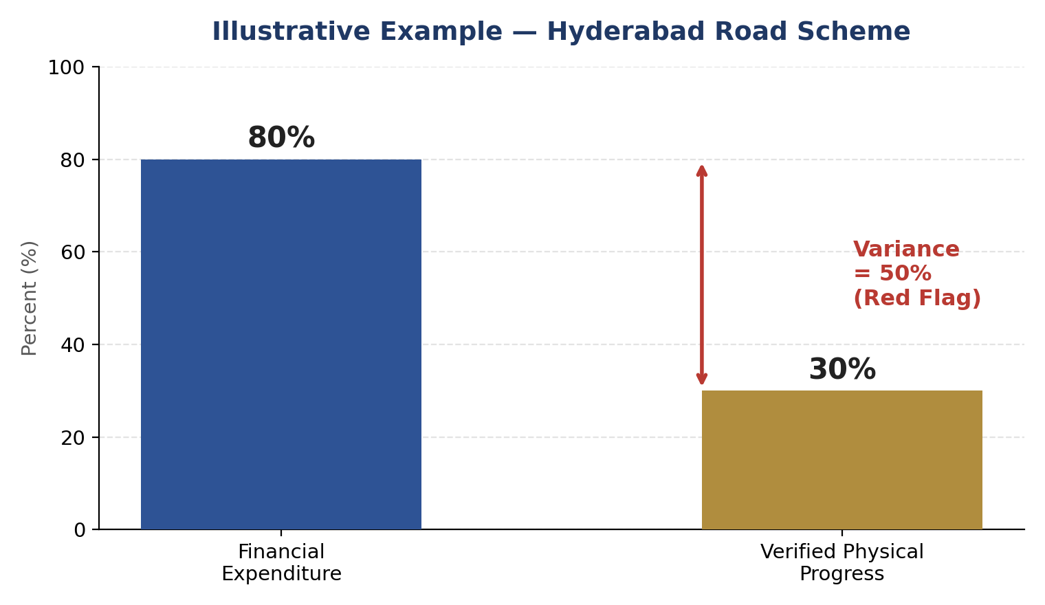
Figure 6 — Variance example: 80% expenditure vs. 30% verified progress
Financial + Physical Data → Variance Calculated
↓
Classified: Normal / Yellow / Red
↓
Red Flag → Alert → Department Notified → Review
↓
Administrative Inquiry / Authorized Decision

Figure 7 — Variance detection and escalation workflow

11.1 Physical Progress Example
Physical progress is computed as a weighted sum across a scheme's defined milestones, not a simple average — giving larger components proportionally more influence on the overall figure.
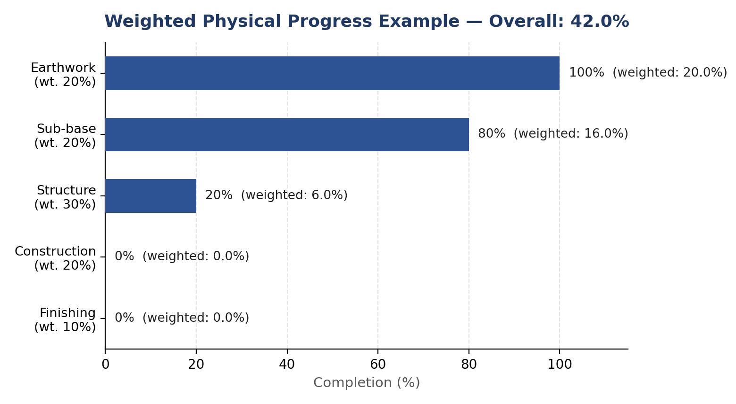
Figure 8 — Weighted milestone progress example (overall physical progress: 42.0%)

12. System Architecture & Technology Stack
The system follows the MERN stack (MongoDB, Express.js, React / React Native, Node.js), with React Native powering the mobile frontend and a Node.js/Express REST API serving as the centralized backend.
React Native Mobile App (offline-first, role-adaptive)
↓
REST API Backend — Node.js + Express.js
↓
Business Logic / Auth / RBAC / Variance Engine
↓
MongoDB (with Geospatial Indexing)
↓
Object Storage (S3 / Cloud Storage) + Redis Cache

Figure 9 — High-level system architecture (MERN stack)
Note: All technologies below are proposed / recommended selections, not yet implemented.
Layer | Proposed Technologies
Mobile (Frontend) | React Native, React Navigation, Zustand, react-native-vision-camera, react-native-image-marker, react-native-geolocation-service, @rnmapbox/maps
Local Storage | op-sqlite + SQLCipher (encrypted offline storage), react-native-keychain (secure tokens)
Backend | Node.js + Express.js (REST API, business logic, authentication)
Database | MongoDB, using its native geospatial (2dsphere) indexing for scheme coordinates and boundaries
Supporting | Redis (cache/queue), S3-compatible / cloud object storage for documents and evidence

13. Data Model
The Scheme is the central entity, linked to a Department, Sector, District, Division, and Location, with related Documents, Milestones, Inspection Assignments, and Financial records.
Entity Group | Key Entities
Organization | Users, Roles, Departments, Sectors, Districts, Divisions
SIMS | Schemes, Scheme Documents, Scheme Locations/Boundaries, Contractors
PMS | Milestones, Inspection Assignments, Inspections, Inspection Photos, Issues
Finance | Allocations, Releases, Expenditures, Variance Records
System | Alerts, Notifications, Audit Logs

14. Functional & Non-Functional Requirements

14.1 Key Functional Requirements
Area | System Behavior
Auth & RBAC | Secure login; four roles, each with defined screens and permissions.
SIMS | Scheme registration, document management, GIS mapping.
Inspection Dispatch | Directors assign inspections to FMOs with deadlines and status tracking.
FMO Inspection | GPS-verified, camera-based inspection with milestone progress and issue logging.
Finance & Variance | Tracks allocation/release/expenditure; computes and classifies variance.
Dashboards & Alerts | Role-based KPIs, filters, and automated notifications.
Offline Sync | Captures inspection data offline; synchronizes automatically once online.
Audit Log | Records key actions with user, timestamp, and change detail.

14.2 Non-Functional Requirements
- Performance: responsive under normal operational load.
- Scalability: supports growth in schemes, users, and inspections across the province.
- Security: RBAC, encrypted storage, HTTPS/TLS, secure token handling.
- Usability: FMO Field Mode kept simple and fast for on-site use.
- Offline Support: full inspection capture without connectivity.
- Auditability: all significant actions traceable to a user and timestamp.

15. Development Roadmap
Phase | Focus
1 | Foundation — requirements, architecture, auth, RBAC, database design
2 | SIMS — registry, documents, GIS map
3 | PMS — inspection dispatch, FMO Field Mode, GPS, camera, evidence
4 | Finance — allocation, releases, expenditure, Variance Engine
5 | Offline Sync — encrypted local storage, background synchronization
6 | Dashboard, Security Hardening, Testing & Pilot Deployment

16. Testing Strategy
- Unit & integration testing across mobile, backend, and database layers.
- Role-based testing to confirm access restrictions per role.
- GPS testing: inside/outside geofence, poor accuracy, mock-location conditions.
- Offline testing: capture without internet, sync on reconnect, retry on failure.
- Financial calculation testing: expenditure, progress, and variance accuracy.
- End-to-end testing of the full Scheme → Inspection → Report → Variance workflow.

17. MVP Scope & Future Enhancements

MVP Scope
Authentication & RBAC, Scheme Registration & Details, Inspection Dispatch, FMO Field Mode with GPS verification and watermarked evidence, Milestone Progress, Finance & Variance Engine, Executive Dashboard, GIS Map, Notifications, Offline Sync, and Audit Logs.

Future Enhancements
- AI-based project risk prediction and inspection report summarization.
- OCR for PC-I documents; satellite/drone imagery integration.
- Predictive delay detection and contractor performance analytics.
- Integration with government treasury systems (subject to approval).

18. Conclusion
The Smart Provincial M&E Management Ecosystem offers a practical, technically achievable path to replacing fragmented scheme monitoring with one integrated platform — combining a centralized registry, GPS-verified field inspections, and financial cross-verification around a shared Variance Engine. The phased roadmap and two-developer work distribution keep the project realistic, with a clearly bounded MVP that already demonstrates the system's full end-to-end value.

